Department of Computer Engineering & Applications

**Institute of Engineering & Technology**



**GLA University**

**Mathura- 281406, INDIA**

**2021-2022**

PROJECT REPORT

**On**

**“AUSPICIOUS”**

**Submitted by**

**Vineet Kumar**

**(201599031)**

**Pawan Singh**

**(191500586)**

**Shreya Gupta**

**(191500783)**

**Department of computer Engineering and Applications**

**GLA University, Mathura**

**17 km. Stone NH#2, Mathura-Delhi Road, P.O. – Chaumuha,**

**Mathura – 281406**





**Declaration**

We hereby declare that the work which is being presented in the Full Stack Project “**Auspicious ”,** in partial fulfillment of the requirements for Mini Project viva voce, is an authentic record of our own work carried by the team members under the supervision of our mentor Mr. Amir Khan.

Group Members: Shreya Gupta (191500783)

Vineet Kumar (201599031)

Pawan Singh (201599017)

Course: B.Tech (Computer Science and Engineering)

Year: 3rd

Semester: 6th

## Supervised By:

Mr.Amir Khan, Technical trainer ,

GLA University, Department of Computer Engineering & Application

**Department of computer Engineering and Applications**

**GLA University, Mathura**

**17 km. Stone NH#2, Mathura-Delhi Road, P.O. – Chaumuha,**

**Mathura – 281406**





**Certificate**

This is to certify that the above statements made by the candidates are correct to the best of my/our knowledge and belief.

_______________________

Supervisor

Mr. Amir Khan

Technical Trainer

Dept of CEA, GLA University

___________________________ Program Coordinator

(Mr. Shashi Shekar)

**About the Project**

Auspicious is a digital tool that includes all of the important details related to the wedding or events that your guests need to know about. Each wedding or event website is totally unique as they are customised to reflect you and your family.

It is based on a template that you can personalise according to your requirements and preferences. It can be accessed from all internet devices, from your desktop to your mobile phone.

Time is precious. It will do the hard work for you and save you valuable time. The difficulties inherent in the planning of any activity are mainly related to the amount of time the development and implementation take, and that is an indisputable fact! Besides, it will achieve more, better and faster.

**Motivation:** Being extremely interested in everything having a relation to web development, the independent project was a great occasion to give me the time to learn and confirm my interest in this field. The fact that we can make our daily life easy and and give the ability to learn us by themselves is both powerful and limitless in terms of application possibilities. We can use web development in Finance, Medicine, and almost everywhere. That’s why I decided to conduct my project around web development.

**Requirements**

**a). Software Requirements:**

* Technology Implemented: HTML,CSS,PHP
* Web Browser: Google Chrome
* Development Environment: VS Code Studio
* GitHub: GitHub is a code hosting platform for version control and collaboration. It lets you and others work together on projects from anywhere. GitHub Repository: A GitHub repository can be used to store a development project. It can contain folders and any type of file. A GitHub repository should also include a license file and a README file about the project. A GitHub repository can also be used to store ideas or any resources that you want to share.
* VS Code Studio: Visual Studio Code is a code editor in layman’s terms. Visual Studio Code is “a free-editor that helps the programmer write code, helps in debugging and corrects the code using the intelli-sense method ”. In normal terms, it facilitates users to write the code in an easy manner. Many people say that it is half of an IDE and an editor, but the decision is up to to the coders. Any program/software that we see or use works on the code that runs in the background. Traditionally coding was used to do in the traditional editors or even in the basic editors like notepad! These editors used to provide basic support to the coders.

**b). Hardware Requirements:**

* Processor Required: Intel i5/8th gen
* Operating System: Windows 10
* RAM: 8GB
* Hardware Devices: Computer System

**Acknowledgment**

We thank the almighty for giving us the courage and perseverance in completing the project. This project itself is an acknowledgment of all those people who have given us their heartfelt cooperation in making this project a grand success. We extend our sincere thanks to Mr. Amir Khan, Technical Trainer at “GLA University, Mathura” for providing her valuable guidance at every stage of this project work. We are profoundly grateful for the unmatched services rendered by him. And last but not least, we would like to express our deep sense of gratitude and earnest thanksgiving to our dear parents for their moral support and heartfelt cooperation in doing the main project.

**Auspicious**

**Abstract**

This application provides an easy way to plan their special events. The user can add all the details of the event and can get the service. The user can select the type of event, type of food to be served, type of decoration and estimated budget. All the details given by users will be verified by admin. Admin will add all the details of the planner based on the requirement of the user and send the user’s event details to the planner. The planner will verify and send his response with a confirmation mail. The user needs to complete the payment process to confirm the order.

**Contents**

**Acknowledgment…………………………………….........**06

**Abstract…………………………………………………**07

1. **Introduction:**

Introduction to Technology used........…......12

**2. The Project**

The client……………………………….2.1

Motivation………………………………2.2

Problem Domain……………………..2.3

About the project……………………2.4

Aim………………………………………….2.5

Objectives……………………………….2.6

Scope of the project ……………….2.7

Structure of Dissertation………….2.8

**3. The Conclusion**

**4. References**

**Chapter 1**

**Introduction**

Auspicious is a digital tool that includes all of the important details related to the wedding or events that your guests need to know about. Each wedding or event website is totally unique as they are customised to reflect you and your family.

It is based on a template that you can personalise according to your requirements and preferences. It can be accessed from all internet devices, from your desktop to your mobile phone.

Time is precious. It will do the hard work for you and save you valuable time. The difficulties inherent in the planning of any activity are mainly related to the amount of time the development and implementation take, and that is an indisputable fact! Besides, it will achieve more, better and faster.

It will not only think about enjoying themselves, but also that their guests spend an unforgettable day. We know that it is priority to you is that the people who are going to share that special day with you feel comfortable and have a lot of fun. To do so, we need to consider the needs of everyone, either the elderly or the little ones, ensuring they enjoy every moment to the full, just like you. From choosing the best entertainment for the little ones, to preventing your ladies’ heels from sinking into the lawn, and that each guest is given your wedding favour or that cone filled with rice / petals to throw over the happy couple as they leave the church. A good wedding planner knows every guest counts, so they will everything in their power to make everyone feel special and cared for.

**Chapter 2**

**The Project**

2.1 The client : The Wedding Planning System is a web-based platform for couples and vendors. Each user has different perspective towards the system, depends on the needs in terms of their roles in the system. Couple Couples are brides and grooms who are initiating their wedding planning. They use the system to help them make decision based on their preference and budget when taking in pricings for their desired wedding services and products. They are responsible for specifying their desires and needs of every aspect of the wedding such as themes, styles, locations, dates, vendor brands and etc. They can make changes anytime during the planning process. Vendor Vendors are persons or companies who provide wedding services and products. They use the system to market their products and services and attract more prospective clients. In addition, they can interact with clients through the system.

1.3 Motivation: Wedding arrangements are the most important things in one’s life and it should be perfect without any mistakes and flaws that needs you to be a magician for managing budgets, bookings, suppliers, guest list and to-do list on a daily basis [1]. Nowadays couples face frustrating situation in looking for wedding products and services here and there and they want support from some other person. Unfortunately, the professional wedding planners are quite expensive and not provide much relevant ideas and schedule to the couple. Even though, there are handful websites which provide information to the user are not more popular in the Sri Lankan culture and they have so many issues as not much user friendly ,questionable relevance to the specific user and doubt with reliability. “Wedding organizer” web application has been proposed as a solution to the current issues which provide important key features which are expected from young couples. They are notifications sending facility as a reminder of events, managing to-do list, manage guest list and enable to find the vendor details

**Problem Domain:** Traditionally, planning a wedding has always been a long process which involves a lot of time, money, effort, stress and high risks. In the modern society due to competitive vendors the wedding has become a fashion for both the couple and their parents [2]. Many brides do not want to take on the stress of planning and stage managing their own wedding. Wedding planners help by providing planning services up to the wedding and coordinating the event on the big day. A wedding planner is a professional who assists with the design, planning and management of a client’s wedding. But their cost is very high and the couple cannot afford it. They provide a key role in making sure that you enjoy your wedding day as you have dreamt of, and they will make sure that all things will go smoothly according to the plan [2]. But wedding planners give their own suggestions and they control the couple’s ideas with their own planning. They are ready to introduce their own dealers who provide commissions for them once the wedding planner will arrange clients. A wedding planner can charge a flat fee for services, tact a percentage on to the key wedding expenditures. Therefore, there is always chance the couple will go over budget and not even realize it. Arranging bridal materials, making guest list and send the invitations are very challenging tasks but wedding planning applications make it too easy. At the wedding day there are series of activities such as speeches, dances, family pictures etc to be done involving many guests but the couple does not have time to waste on finding the right guest for each activity. The proposed system has ‘Task Management’ function that assign ownership of each task to the couple’s family members and keep track of their progress. It will help the wedding couple to enjoy the wedding day without any hassle.

**About the project:** Mainly this project is focused on couples who face frustrating situation in looking for wedding products and services here and there, and vendors who have difficulties to expand their customer base. The Wedding Planning System designed to be a one-stop web-based platform used by couples and vendors. Each user has different perspective towards the system, depends on the needs in terms of their roles in the system. Couples use the system on their wedding design, plan and management. Vendors use the system to sell their services and products.

**Aim:** The aim of this project is to help wedding couples to specify their desires and needs of every aspect of the wedding such as themes, styles, locations, dates, vendor brands and more and vendors to expand their market.

**Objectives:** The “wedding organizer” is a web based platform that aims to help organize successful wedding event. The system assists the couples in the decision making and planning processes associated with all aspects of a wedding organization. The system offers features that the couples can retrieve information for wedding products and services as well as information of vendors in the shortest possible time. Also, vendors can gain benefit of getting more recognition from clients and generating more revenue. The proposed system has the ability to explore wedding goods/service suppliers (Vendors) across thirteen relevant categories and allow vendors to enter and manage all relevant information such as price, client list, models, previous work details, locations, exhibition details and more. Wedding couple has the ability to register themselves in the web application by entering name of the bride, name of the groom, and date of wedding. Managing the guest list is another important task provide by the proposed system. Check who has already confirmed and who has not. Balancing the budget is one of the hardest aspects of planning a wedding. The wedding couple has not experience of dealing with paying vendor in the countdown to a wedding. Most couples have never thrown a celebration like a wedding before. Therefore, they do not know how to budget for a wedding [2]. The proposed system will help the wedding couple to figure out a budget for the event that is just right for them. It will also help them to stay within budget when planning their big day. So many things that need to be done on the wedding and prior this day. So planning is very important to make the wedding day special and memorable. The wedding checklist is generated for that. It helps to prepare for the big day without missing any of the bits and pieces that involved in planning

**Scope of the project:** The proposed system will be a comprehensive web based wedding planning system designed using PHP. This system will be capable of planning, scheduling, monitoring and evaluating all the activities related to the wedding. The web application will let the couple to manage the budget against the supplier’s goods and services. It will also help them to stay within budget when planning their big day. The proposed system is intended to cover the following functional aspects: Wedding couple Registration Wedding couples have ability to register themselves in the web application. Name of the bride and groom, wedding date, and homecoming date are needed. Explore wedding goods/service suppliers (Vendors) The bride or groom will be able to find suppliers across thirteen relevant categories using extensive filters such as cost, location or other required factors. Following are the thirteen categories:

- Venues

- Catering

- Photographers

- Videographers

- DJ/Band

- Wedding car

- Flowers & decorations

- Wedding jewelry

- Wedding cakes

- Wedding invitations

- Bridal Accessories

- Groom Accessories

- Health & Beauty

Wedding Checklist Check items as done, and keep a track of the pending ones with own wedding countdown. See what percentage have finished, and keep track of what still needs to be done. Guest List Keep track of guest status. Build your wedding guest list and easily keep track of guest attendance. Task management Has the ability to assign ownership of each task with your family members and keep track of their progress. Budget Calculation Manage the cost of individual expenditure items (DJ, Florist, photographers …etc,) and all the amounts are immediately added once the couple finalize vendors Keep the track of payments such as actual cost incurred, estimated cost, amount paid and amount need to be paid.

**Structure of Dissertation :** In background chapter a review of similar systems will be provided. A comparison of alternative design strategies will also be included in this chapter. Compare how the project requirement are satisfied through each alternative as well as the costs involved in each and select with justification a single design strategy for implementation. The design of the system will be described in methodology chapter. The implementation environment (hardware/ software), tools, existing systems that reused, database table structures, backup strategy design, test plan, etc will also include in this chapter. Evaluation chapter will give a critical evaluation of the system. It will discuss whether the project objectives were satisfied and if not, the reason for them. Lesson learnt during the course of the project will also be expanded upon. Provide all the aspects of the system have been tested and specification has been me

**CHAPTER 3**

**THE CONCLUSION**

**Conclusion** :The goal of this project is to build a web based wedding planning system to help organize successful wedding event. The system assists the couples in the decision making and planning processes associated with all aspects of a wedding organization. The system offers features that the couples can retrieve information for wedding products and services as well as information of vendors in the shortest possible time. Also, vendors can gain benefit of getting more recognition from clients and generating more revenue. The system enables wedding users to manage guest list, checklist and task management. The users can request for pricing from vendors through the system and manage their budget for the big day. The system enables all users to access to it any time anywhere. In previous chapter, the design and implementation of this system is discussed by using conceptual methodology. Many challenges faced during the design and implementation phase of this system. Dealing and understanding the end user requirements was a major concern. Even though there are many existing components available in the market users do have lots of problems in those modules. As mentioned in the literature reviews there are some open source components available for this type of wedding planning systems, it is unable to apply the end user requirements, due to the complexity. Therefore system was developed from the scratch according to the requirements by using web programming languages. So, had to go through a detailed learning of PHP, java Scripts, Ajax, Html & MySQL databases. The system was unit tested properly during the development stages. It helped to reduce the number of defects in the final product. However while the implementation was in progress, errors that were not anticipated in the testing plan cropped up. Those errors would have to fix before final release of the system.

**webpage:**

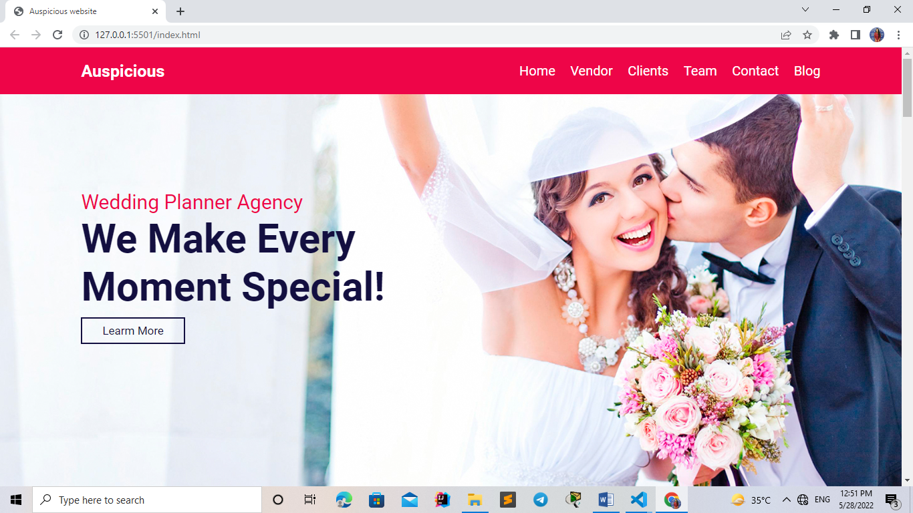

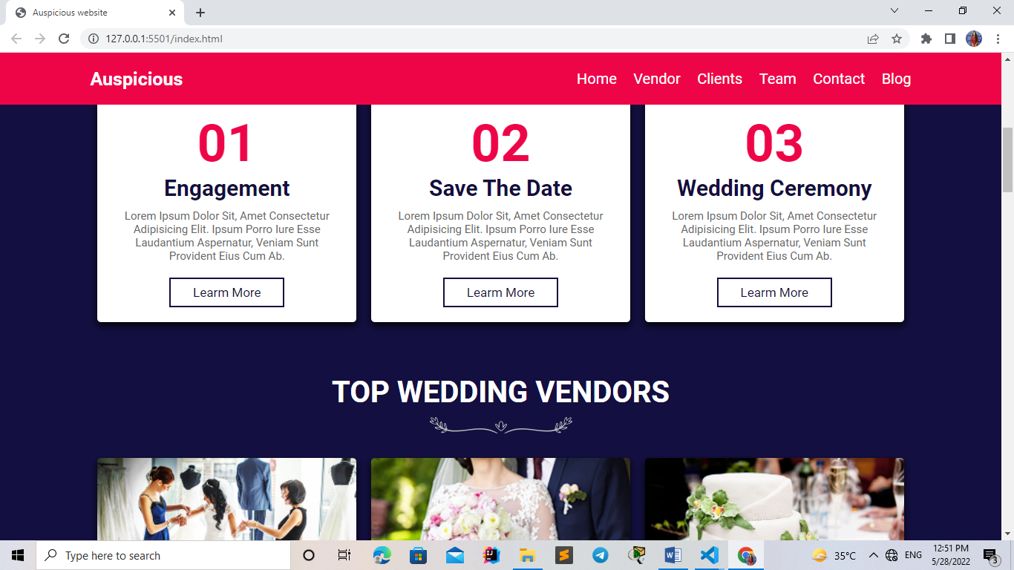

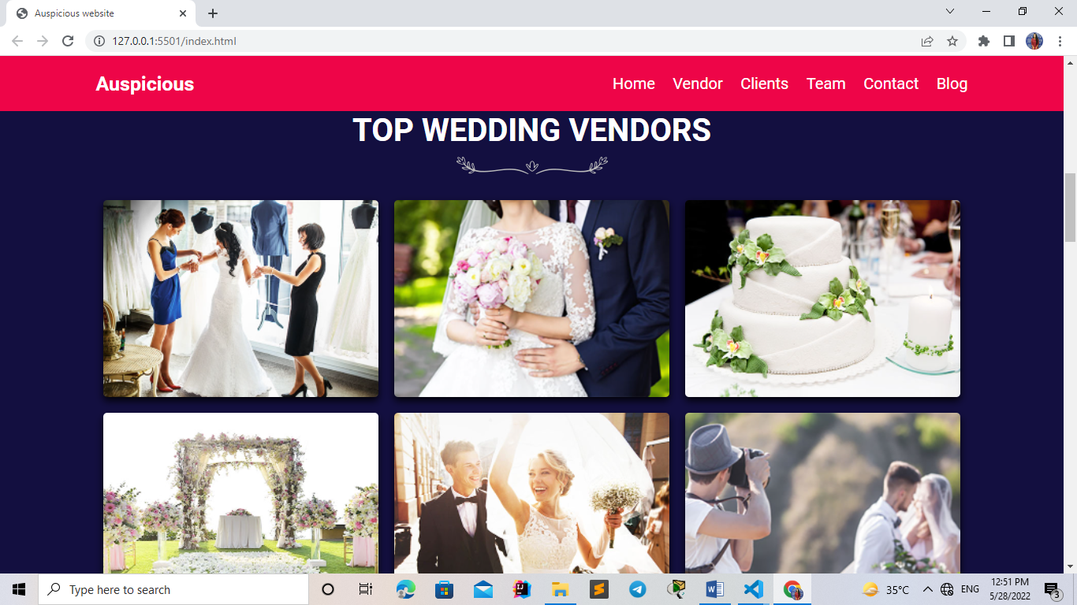

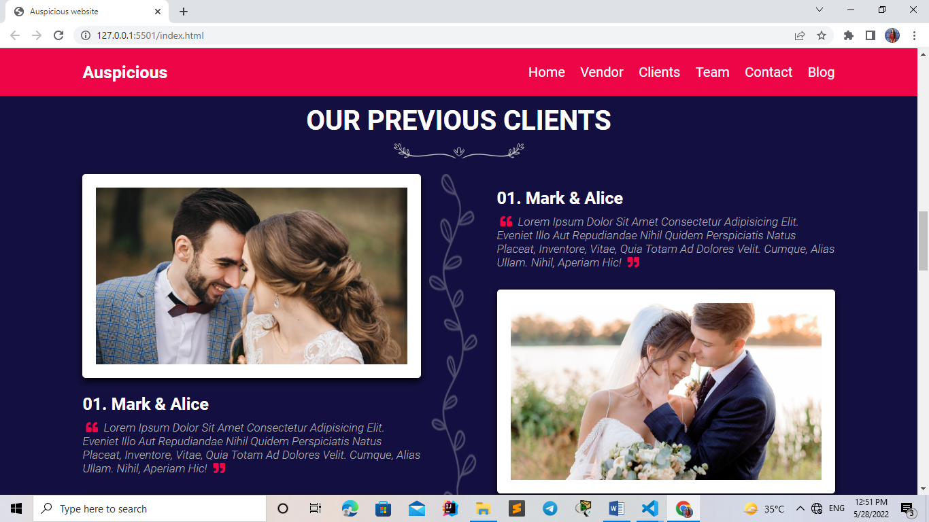

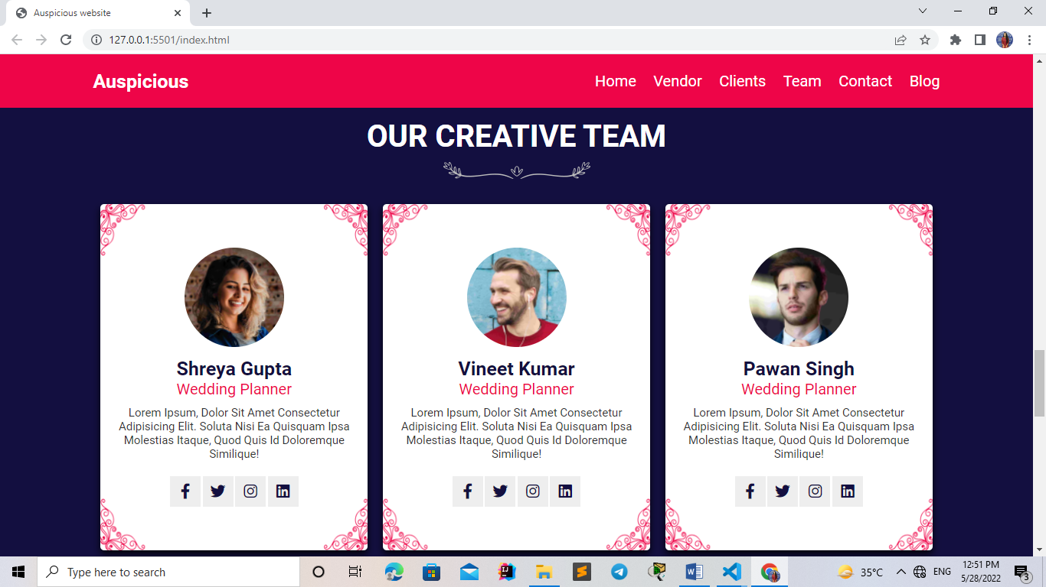

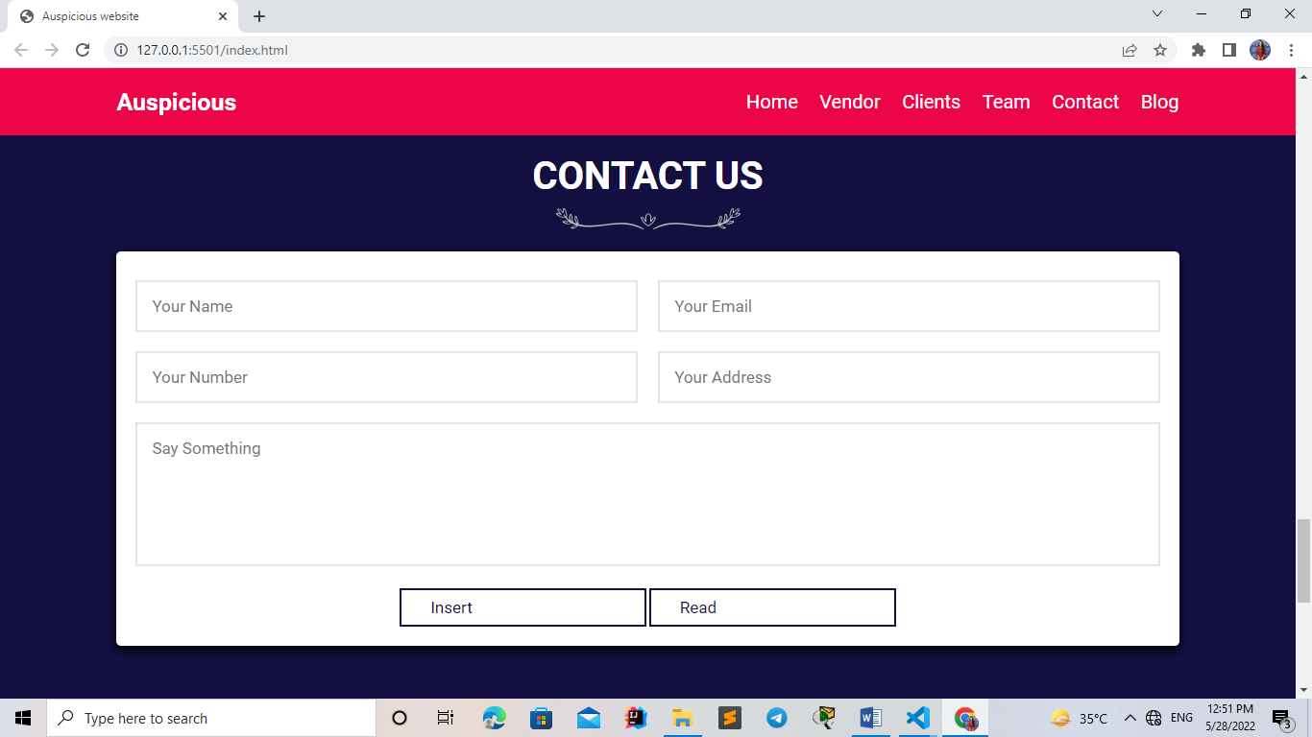

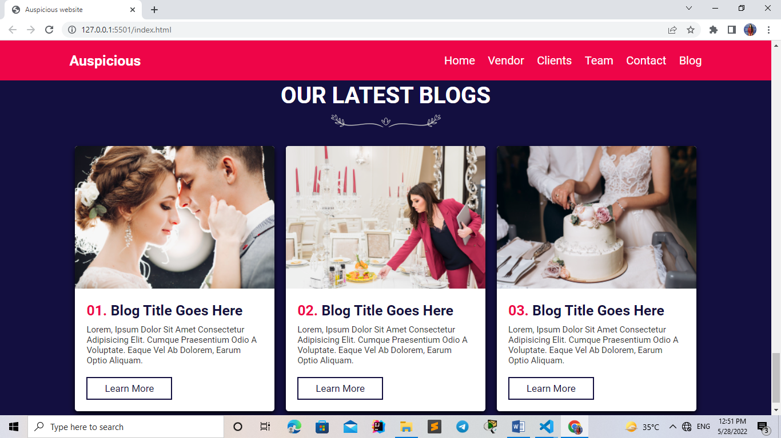

**Code:**

**HTML**

<!DOCTYPE html>

<html lang="en">

<head>

    <meta charset="UTF-8">

    <meta name="viewport" content="width=device-width, initial-scale=1.0">

    <title>Auspicious website</title>

    <!-- font awesome cdn link  -->

    <link rel="stylesheet" href="https://cdnjs.cloudflare.com/ajax/libs/font-awesome/5.15.3/css/all.min.css">

    <!-- custom css file link  -->

    <link rel="stylesheet" href="css/style.css">

</head>

<body>

<!-- header section starts  -->

<header>

    <a href="#" class="logo">Auspicious</a>

    <div id="menu-bar" class="fas fa-bars"></div>

    <nav class="navbar">

        <a href="#home">home</a>

        <a href="#vendor">vendor</a>

        <a href="#clients">clients</a>

        <a href="#team">team</a>

        <a href="#contact">contact</a>

        <a href="#blog">blog</a>

    </nav>

</header>

<!-- header section ends -->

<!-- home section starts  -->

<section class="home" id="home">

    <div class="content">

        <span>wedding planner agency</span>

        <h3>we make every moment special!</h3>

        <a href="#" class="btn">learm more</a>

    </div>

</section>

<!-- home section ends -->

<section class="step-container">

    <div class="step">

        <span>01</span>

        <h3>engagement</h3>

        <p>Lorem ipsum dolor sit, amet consectetur adipisicing elit. Ipsum porro iure esse laudantium aspernatur, veniam sunt provident eius cum ab.</p>

        <a href="#" class="btn">learm more</a>

    </div>

    <div class="step">

        <span>02</span>

        <h3>save the date</h3>

        <p>Lorem ipsum dolor sit, amet consectetur adipisicing elit. Ipsum porro iure esse laudantium aspernatur, veniam sunt provident eius cum ab.</p>

        <a href="#" class="btn">learm more</a>

    </div>

    <div class="step">

        <span>03</span>

        <h3>wedding ceremony</h3>

        <p>Lorem ipsum dolor sit, amet consectetur adipisicing elit. Ipsum porro iure esse laudantium aspernatur, veniam sunt provident eius cum ab.</p>

        <a href="#" class="btn">learm more</a>

    </div>

</section>

<!-- vendor section starts  -->

<section class="vendor" id="vendor">

    <div class="heading">

        <h1>top wedding vendors</h1>

        <img src="images/header-img.png" alt="">

    </div>

    <div class="box-container">

        <div class="box">

            <img src="images/img1.jpg" alt="">

            <div class="info">

                <h3>dressing</h3>

                <p>Lorem, ipsum dolor sit amet consectetur adipisicing elit. Veniam, dolores.</p>

                <a href="#" class="btn">learm more</a>

            </div>

        </div>

        <div class="box">

            <img src="images/img2.jpg" alt="">

            <div class="info">

                <h3>Florist</h3>

                <p>Lorem, ipsum dolor sit amet consectetur adipisicing elit. Veniam, dolores.</p>

                <a href="#" class="btn">learm more</a>

            </div>

        </div>

        <div class="box">

            <img src="images/img3.jpg" alt="">

            <div class="info">

                <h3>wedding cake</h3>

                <p>Lorem, ipsum dolor sit amet consectetur adipisicing elit. Veniam, dolores.</p>

                <a href="#" class="btn">learm more</a>

            </div>

        </div>

        <div class="box">

            <img src="images/img4.jpg" alt="">

            <div class="info">

                <h3>venu and hall</h3>

                <p>Lorem, ipsum dolor sit amet consectetur adipisicing elit. Veniam, dolores.</p>

                <a href="#" class="btn">learm more</a>

            </div>

        </div>

        <div class="box">

            <img src="images/img5.jpg" alt="">

            <div class="info">

                <h3>music and party</h3>

                <p>Lorem, ipsum dolor sit amet consectetur adipisicing elit. Veniam, dolores.</p>

                <a href="#" class="btn">learm more</a>

            </div>

        </div>

        <div class="box">

            <img src="images/img6.jpg" alt="">

            <div class="info">

                <h3>photographer</h3>

                <p>Lorem, ipsum dolor sit amet consectetur adipisicing elit. Veniam, dolores.</p>

                <a href="#" class="btn">learm more</a>

            </div>

        </div>

    </div>

</section>

<!-- vendor section ends -->

<!-- client section starts  -->

<section class="clients" id="clients">

    <div class="heading">

        <h1>our previous clients</h1>

        <img src="images/header-img.png" alt="">

    </div>

    <div class="row">

        <div class="box-container">

            <div class="box">

                <img src="images/client-1.jpg" alt="">

                <div class="info">

                    <h3>01. mark & alice</h3>

                    <p> <i class="fas fa-quote-left"></i> Lorem ipsum dolor sit amet consectetur adipisicing elit. Eveniet illo aut repudiandae nihil quidem perspiciatis natus placeat, inventore, vitae, quia totam ad dolores velit. Cumque, alias ullam. Nihil, aperiam hic! <i class="fas fa-quote-right"></i> </p>

                </div>

            </div>

            <div class="box">

                <img src="images/client-2.jpg" alt="">

                <div class="info">

                    <h3>01. mark & alice</h3>

                    <p> <i class="fas fa-quote-left"></i> Lorem ipsum dolor sit amet consectetur adipisicing elit. Eveniet illo aut repudiandae nihil quidem perspiciatis natus placeat, inventore, vitae, quia totam ad dolores velit. Cumque, alias ullam. Nihil, aperiam hic! <i class="fas fa-quote-right"></i> </p>

                </div>

            </div>

        </div>

        <img src="images/divider.png" class="divider" alt="">

        <div class="box-container">

            <div class="box">

                <div class="info">

                    <h3>01. mark & alice</h3>

                    <p> <i class="fas fa-quote-left"></i> Lorem ipsum dolor sit amet consectetur adipisicing elit. Eveniet illo aut repudiandae nihil quidem perspiciatis natus placeat, inventore, vitae, quia totam ad dolores velit. Cumque, alias ullam. Nihil, aperiam hic! <i class="fas fa-quote-right"></i> </p>

                </div>

                <img src="images/client-3.jpg" alt="">

            </div>

            <div class="box">

                <div class="info">

                    <h3>01. mark & alice</h3>

                    <p> <i class="fas fa-quote-left"></i> Lorem ipsum dolor sit amet consectetur adipisicing elit. Eveniet illo aut repudiandae nihil quidem perspiciatis natus placeat, inventore, vitae, quia totam ad dolores velit. Cumque, alias ullam. Nihil, aperiam hic! <i class="fas fa-quote-right"></i> </p>

                </div>

                <img src="images/client-4.jpg" alt="">

            </div>

        </div>

    </div>

</section>

<!-- client section ends -->

<!-- team section starts  -->

<section class="team" id="team">

    <div class="heading">

        <h1>our creative team</h1>

        <img src="images/header-img.png" alt="">

    </div>

    <div class="box-container">

        <div class="box">

            <img src="images/team-1.png" alt="">

            <h3>Mark Smith</h3>

            <span>wedding planner</span>

            <p>Lorem ipsum, dolor sit amet consectetur adipisicing elit. Soluta nisi ea quisquam ipsa molestias itaque, quod quis id doloremque similique!</p>

            <div class="share">

                <a href="#" class="fab fa-facebook-f"></a>

                <a href="#" class="fab fa-twitter"></a>

                <a href="#" class="fab fa-instagram"></a>

                <a href="#" class="fab fa-linkedin"></a>

            </div>

        </div>

        <div class="box">

            <img src="images/team-2.png" alt="">

            <h3>Joe Baden</h3>

            <span>wedding planner</span>

            <p>Lorem ipsum, dolor sit amet consectetur adipisicing elit. Soluta nisi ea quisquam ipsa molestias itaque, quod quis id doloremque similique!</p>

            <div class="share">

                <a href="#" class="fab fa-facebook-f"></a>

                <a href="#" class="fab fa-twitter"></a>

                <a href="#" class="fab fa-instagram"></a>

                <a href="#" class="fab fa-linkedin"></a>

            </div>

        </div>

        <div class="box">

            <img src="images/team-3.png" alt="">

            <h3>Zac Marshel</h3>

            <span>wedding planner</span>

            <p>Lorem ipsum, dolor sit amet consectetur adipisicing elit. Soluta nisi ea quisquam ipsa molestias itaque, quod quis id doloremque similique!</p>

            <div class="share">

                <a href="#" class="fab fa-facebook-f"></a>

                <a href="#" class="fab fa-twitter"></a>

                <a href="#" class="fab fa-instagram"></a>

                <a href="#" class="fab fa-linkedin"></a>

            </div>

        </div>

    </div>

</section>

<!-- team section ends -->

<!-- contact section starts  -->

<section class="contact" id="contact">

    <div class="heading">

        <h1>contact us</h1>

        <img src="images/header-img.png" alt="">

    </div>

    <form action="" method="">

        <div class="inputBox">

            <input type="text" placeholder="your name" id="name" name="name">

            <input type="email" placeholder="your email" name="email" id="email">

        </div>

        <div class="inputBox">

            <input type="number" placeholder="your number" name="number" id="number">

            <input type="text" placeholder="your address" name="address" id="address">

        </div>

        <textarea placeholder="say something" name="msg" id="msg" cols="30" rows="10"></textarea>

        <input type="insert" value="insert" class="btn" id="insert">

        <input type="read" value="read" class="btn" id="read">

    </form>

</section>

<!-- contact section ends -->

<!-- blog section starts  -->

<section class="blog" id="blog">

    <div class="heading">

        <h1>our latest blogs</h1>

        <img src="images/header-img.png" alt="">

    </div>

    <div class="box-container">

        <div class="box">

            <img src="images/blog-1.jpg" alt="">

            <div class="info">

                <h3> <span>01. </span> blog title goes here </h3>

                <p>Lorem, ipsum dolor sit amet consectetur adipisicing elit. Cumque praesentium odio a voluptate. Eaque vel ab dolorem, earum optio aliquam.</p>

                <a href="#" class="btn">learn more</a>

            </div>

        </div>

        <div class="box">

            <img src="images/blog-2.jpg" alt="">

            <div class="info">

                <h3> <span>02. </span> blog title goes here </h3>

                <p>Lorem, ipsum dolor sit amet consectetur adipisicing elit. Cumque praesentium odio a voluptate. Eaque vel ab dolorem, earum optio aliquam.</p>

                <a href="#" class="btn">learn more</a>

            </div>

        </div>

        <div class="box">

            <img src="images/blog-3.jpg" alt="">

            <div class="info">

                <h3> <span>03. </span> blog title goes here </h3>

                <p>Lorem, ipsum dolor sit amet consectetur adipisicing elit. Cumque praesentium odio a voluptate. Eaque vel ab dolorem, earum optio aliquam.</p>

                <a href="#" class="btn">learn more</a>

            </div>

        </div>

    </div>

</section>

<!-- blog section ends-->

<!-- footer section  -->

<script>

let menu = document.querySelector('#menu-bar');

let navbar = document.querySelector('.navbar');

menu.addEventListener('click', () =>{

    menu.classList.toggle('fa-times');

    navbar.classList.toggle('nav-toggle');

});

window.onscroll = () =>{

    menu.classList.remove('fa-times');

    navbar.classList.remove('nav-toggle');

}

</script>

<script src="https://www.gstatic.com/firebasejs/8.4.2/firebase.js"></script>

    <script src="./fireConfig.js"></script>

    <script src="./myscript.js"></script>

</body>

</html>

## CSS FILE:

<!DOCTYPE html>

<html lang="en">

<head>

    <meta charset="UTF-8">

    <meta name="viewport" content="width=device-width, initial-scale=1.0">

    <title>Auspicious website</title>

    <!-- font awesome cdn link  -->

    <link rel="stylesheet" href="https://cdnjs.cloudflare.com/ajax/libs/font-awesome/5.15.3/css/all.min.css">

    <!-- custom css file link  -->

    <link rel="stylesheet" href="css/style.css">

</head>

<body>

<!-- header section starts  -->

<header>

    <a href="#" class="logo">Auspicious</a>

    <div id="menu-bar" class="fas fa-bars"></div>

    <nav class="navbar">

        <a href="#home">home</a>

        <a href="#vendor">vendor</a>

        <a href="#clients">clients</a>

        <a href="#team">team</a>

        <a href="#contact">contact</a>

        <a href="#blog">blog</a>

    </nav>

</header>

<!-- header section ends -->

<!-- home section starts  -->

<section class="home" id="home">

    <div class="content">

        <span>wedding planner agency</span>

        <h3>we make every moment special!</h3>

        <a href="#" class="btn">learm more</a>

    </div>

</section>

<!-- home section ends -->

<section class="step-container">

    <div class="step">

        <span>01</span>

        <h3>engagement</h3>

        <p>Lorem ipsum dolor sit, amet consectetur adipisicing elit. Ipsum porro iure esse laudantium aspernatur, veniam sunt provident eius cum ab.</p>

        <a href="#" class="btn">learm more</a>

    </div>

    <div class="step">

        <span>02</span>

        <h3>save the date</h3>

        <p>Lorem ipsum dolor sit, amet consectetur adipisicing elit. Ipsum porro iure esse laudantium aspernatur, veniam sunt provident eius cum ab.</p>

        <a href="#" class="btn">learm more</a>

    </div>

    <div class="step">

        <span>03</span>

        <h3>wedding ceremony</h3>

        <p>Lorem ipsum dolor sit, amet consectetur adipisicing elit. Ipsum porro iure esse laudantium aspernatur, veniam sunt provident eius cum ab.</p>

        <a href="#" class="btn">learm more</a>

    </div>

</section>

<!-- vendor section starts  -->

<section class="vendor" id="vendor">

    <div class="heading">

        <h1>top wedding vendors</h1>

        <img src="images/header-img.png" alt="">

    </div>

    <div class="box-container">

        <div class="box">

            <img src="images/img1.jpg" alt="">

            <div class="info">

                <h3>dressing</h3>

                <p>Lorem, ipsum dolor sit amet consectetur adipisicing elit. Veniam, dolores.</p>

                <a href="#" class="btn">learm more</a>

            </div>

        </div>

        <div class="box">

            <img src="images/img2.jpg" alt="">

            <div class="info">

                <h3>Florist</h3>

                <p>Lorem, ipsum dolor sit amet consectetur adipisicing elit. Veniam, dolores.</p>

                <a href="#" class="btn">learm more</a>

            </div>

        </div>

        <div class="box">

            <img src="images/img3.jpg" alt="">

            <div class="info">

                <h3>wedding cake</h3>

                <p>Lorem, ipsum dolor sit amet consectetur adipisicing elit. Veniam, dolores.</p>

                <a href="#" class="btn">learm more</a>

            </div>

        </div>

        <div class="box">

            <img src="images/img4.jpg" alt="">

            <div class="info">

                <h3>venu and hall</h3>

                <p>Lorem, ipsum dolor sit amet consectetur adipisicing elit. Veniam, dolores.</p>

                <a href="#" class="btn">learm more</a>

            </div>

        </div>

        <div class="box">

            <img src="images/img5.jpg" alt="">

            <div class="info">

                <h3>music and party</h3>

                <p>Lorem, ipsum dolor sit amet consectetur adipisicing elit. Veniam, dolores.</p>

                <a href="#" class="btn">learm more</a>

            </div>

        </div>

        <div class="box">

            <img src="images/img6.jpg" alt="">

            <div class="info">

                <h3>photographer</h3>

                <p>Lorem, ipsum dolor sit amet consectetur adipisicing elit. Veniam, dolores.</p>

                <a href="#" class="btn">learm more</a>

            </div>

        </div>

    </div>

</section>

<!-- vendor section ends -->

<!-- client section starts  -->

<section class="clients" id="clients">

    <div class="heading">

        <h1>our previous clients</h1>

        <img src="images/header-img.png" alt="">

    </div>

    <div class="row">

        <div class="box-container">

            <div class="box">

                <img src="images/client-1.jpg" alt="">

                <div class="info">

                    <h3>01. mark & alice</h3>

                    <p> <i class="fas fa-quote-left"></i> Lorem ipsum dolor sit amet consectetur adipisicing elit. Eveniet illo aut repudiandae nihil quidem perspiciatis natus placeat, inventore, vitae, quia totam ad dolores velit. Cumque, alias ullam. Nihil, aperiam hic! <i class="fas fa-quote-right"></i> </p>

                </div>

            </div>

            <div class="box">

                <img src="images/client-2.jpg" alt="">

                <div class="info">

                    <h3>01. mark & alice</h3>

                    <p> <i class="fas fa-quote-left"></i> Lorem ipsum dolor sit amet consectetur adipisicing elit. Eveniet illo aut repudiandae nihil quidem perspiciatis natus placeat, inventore, vitae, quia totam ad dolores velit. Cumque, alias ullam. Nihil, aperiam hic! <i class="fas fa-quote-right"></i> </p>

                </div>

            </div>

        </div>

        <img src="images/divider.png" class="divider" alt="">

        <div class="box-container">

            <div class="box">

                <div class="info">

                    <h3>01. mark & alice</h3>

                    <p> <i class="fas fa-quote-left"></i> Lorem ipsum dolor sit amet consectetur adipisicing elit. Eveniet illo aut repudiandae nihil quidem perspiciatis natus placeat, inventore, vitae, quia totam ad dolores velit. Cumque, alias ullam. Nihil, aperiam hic! <i class="fas fa-quote-right"></i> </p>

                </div>

                <img src="images/client-3.jpg" alt="">

            </div>

            <div class="box">

                <div class="info">

                    <h3>01. mark & alice</h3>

                    <p> <i class="fas fa-quote-left"></i> Lorem ipsum dolor sit amet consectetur adipisicing elit. Eveniet illo aut repudiandae nihil quidem perspiciatis natus placeat, inventore, vitae, quia totam ad dolores velit. Cumque, alias ullam. Nihil, aperiam hic! <i class="fas fa-quote-right"></i> </p>

                </div>

                <img src="images/client-4.jpg" alt="">

            </div>

        </div>

    </div>

</section>

<!-- client section ends -->

<!-- team section starts  -->

<section class="team" id="team">

    <div class="heading">

        <h1>our creative team</h1>

        <img src="images/header-img.png" alt="">

    </div>

    <div class="box-container">

        <div class="box">

            <img src="images/team-1.png" alt="">

            <h3>Mark Smith</h3>

            <span>wedding planner</span>

            <p>Lorem ipsum, dolor sit amet consectetur adipisicing elit. Soluta nisi ea quisquam ipsa molestias itaque, quod quis id doloremque similique!</p>

            <div class="share">

                <a href="#" class="fab fa-facebook-f"></a>

                <a href="#" class="fab fa-twitter"></a>

                <a href="#" class="fab fa-instagram"></a>

                <a href="#" class="fab fa-linkedin"></a>

            </div>

        </div>

        <div class="box">

            <img src="images/team-2.png" alt="">

            <h3>Joe Baden</h3>

            <span>wedding planner</span>

            <p>Lorem ipsum, dolor sit amet consectetur adipisicing elit. Soluta nisi ea quisquam ipsa molestias itaque, quod quis id doloremque similique!</p>

            <div class="share">

                <a href="#" class="fab fa-facebook-f"></a>

                <a href="#" class="fab fa-twitter"></a>

                <a href="#" class="fab fa-instagram"></a>

                <a href="#" class="fab fa-linkedin"></a>

            </div>

        </div>

        <div class="box">

            <img src="images/team-3.png" alt="">

            <h3>Zac Marshel</h3>

            <span>wedding planner</span>

            <p>Lorem ipsum, dolor sit amet consectetur adipisicing elit. Soluta nisi ea quisquam ipsa molestias itaque, quod quis id doloremque similique!</p>

            <div class="share">

                <a href="#" class="fab fa-facebook-f"></a>

                <a href="#" class="fab fa-twitter"></a>

                <a href="#" class="fab fa-instagram"></a>

                <a href="#" class="fab fa-linkedin"></a>

            </div>

        </div>

    </div>

</section>

<!-- team section ends -->

<!-- contact section starts  -->

<section class="contact" id="contact">

    <div class="heading">

        <h1>contact us</h1>

        <img src="images/header-img.png" alt="">

    </div>

    <form action="" method="">

        <div class="inputBox">

            <input type="text" placeholder="your name" id="name" name="name">

            <input type="email" placeholder="your email" name="email" id="email">

        </div>

        <div class="inputBox">

            <input type="number" placeholder="your number" name="number" id="number">

            <input type="text" placeholder="your address" name="address" id="address">

        </div>

        <textarea placeholder="say something" name="msg" id="msg" cols="30" rows="10"></textarea>

        <input type="insert" value="insert" class="btn" id="insert">

        <input type="read" value="read" class="btn" id="read">

    </form>

</section>

<!-- contact section ends -->

<!-- blog section starts  -->

<section class="blog" id="blog">

    <div class="heading">

        <h1>our latest blogs</h1>

        <img src="images/header-img.png" alt="">

    </div>

    <div class="box-container">

        <div class="box">

            <img src="images/blog-1.jpg" alt="">

            <div class="info">

                <h3> <span>01. </span> blog title goes here </h3>

                <p>Lorem, ipsum dolor sit amet consectetur adipisicing elit. Cumque praesentium odio a voluptate. Eaque vel ab dolorem, earum optio aliquam.</p>

                <a href="#" class="btn">learn more</a>

            </div>

        </div>

        <div class="box">

            <img src="images/blog-2.jpg" alt="">

            <div class="info">

                <h3> <span>02. </span> blog title goes here </h3>

                <p>Lorem, ipsum dolor sit amet consectetur adipisicing elit. Cumque praesentium odio a voluptate. Eaque vel ab dolorem, earum optio aliquam.</p>

                <a href="#" class="btn">learn more</a>

            </div>

        </div>

        <div class="box">

            <img src="images/blog-3.jpg" alt="">

            <div class="info">

                <h3> <span>03. </span> blog title goes here </h3>

                <p>Lorem, ipsum dolor sit amet consectetur adipisicing elit. Cumque praesentium odio a voluptate. Eaque vel ab dolorem, earum optio aliquam.</p>

                <a href="#" class="btn">learn more</a>

            </div>

        </div>

    </div>

</section>

<!-- blog section ends-->

<!-- footer section  -->

<script>

let menu = document.querySelector('#menu-bar');

let navbar = document.querySelector('.navbar');

menu.addEventListener('click', () =>{

    menu.classList.toggle('fa-times');

    navbar.classList.toggle('nav-toggle');

});

window.onscroll = () =>{

    menu.classList.remove('fa-times');

    navbar.classList.remove('nav-toggle');

}

</script>

<script src="https://www.gstatic.com/firebasejs/8.4.2/firebase.js"></script>

    <script src="./fireConfig.js"></script>

    <script src="./myscript.js"></script>

</body>

</html>

**4. References:**

[1] "What are some good wedding planning apps," Quora, [Online]. Available: www.quora.com/what-aresome-goog-wedding-planning-web-apps. [Accessed 20 August 2018].

[2] "Home:Our Wedding Sri Lanka- For All Your Wedding Dreams," 2010-2016 ourweddingsrilanka.com. All right reserved., 2010. [Online]. Available: https://ourweddingsrilanka.com. [Accessed 18 May 2018].

[3] N. Davis, Bridal style, Rizzoli International Publications, 2000.

[4] S. Coontz, Marriage, a history: How love conquered marriage. New York, NY:, Penguin Books.

. [5] Stephanie Coontz, "Bridezilla’s revenge. Psychology Today, 38(3), 80-82.," 1 may 2005. [Online]. Available: https://www.psychologytoday.com/us/articles/200505/bridezillas-revenge. [Accessed 5 september 2018].

[6] E. P. (. Cele C. Otnes (Author), Cinderella Dreams:The allure of the lavish wedding, octomber, 2003. [7] C. Grossman, "Average couple spends $26,989 on wedding; many break budget. USA Today.," 10 August 2012. [Online]. Available: http://usatoday30.usatoday.com/money/perfi/basics/story/2012-08- 09/wedding-costs/56921020/1. [Accessed 30 10 2018].

[8] E. Engstrom, "Unraveling the knot: Political economy and cultural hegemony in wedding media -Journal of Communication Inquiry, 32(1), 60-82.," 2008. [Online]. Available: http://jci.sagepub.com/content/32/1/60.abstract. [Accessed 30 10 2018].

[9] M. J. L. S. &. C. T. Daniels, "The attributes influencing wedding reception venue selection. Event Management, 16(3), 245-258.," 2012. [Online]. Available: https://www.cognizantcommunication.com/journal-titles/event-management

**5. Bibliography:**

### [1] The Full Stack Developer

[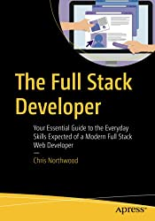](https://www.amazon.com/gp/product/1484241517/ref=as_li_tl?ie=UTF8&camp=1789&creative=9325&creativeASIN=1484241517&linkCode=as2&tag=booksoncode-20&linkId=40e3318de92a3ddaad2a0e6b41fc6b8a)

[The Full Stack Developer: Your Essential Guide to the Everyday Skills Expected of a Modern Full Stack Web Developer](https://amzn.to/3grZurL) by Chris Northwood recognizes skills beyond the technical and gives foundational knowledge of the wide set of skills needed in a modern software development team

[2] Modern Full-Stack De[Modern Full-Stack Development: Using TypeScript, React, Node.js, Webpack, and Docker](https://amzn.to/3wnfGkT) by Frank Zammetti build a solid foundation of knowledge and quickly expand it by constructing two different real-world apps.

### velopment